[1]

CRYPTOGRAPHY IN NETWORKING AND NETWORK SECURITY

First A. Author, *Fellow, IEEE*, Second B. Author, and Third C. Author, Jr., *Member, IEEE*

***Abstract*—** **Due to the emergence of the Internet and the expansion of e-commerce platforms and social media platforms, organisations all across the globe generate massive amounts of content in a regular routine. Data security is the most important consideration when it comes to guaranteeing the secure transfer of information over the internet. Internet safety issues are growing increasingly important as civilization develops into an electronic media future. As additional individuals get on to the internet, it draws a growing number of cybercriminals. It refers to the network administrator's control over access to information on the network. Networking safety includes just not terminal privacy rather includes the reliability of the entire infrastructure. This document makes an endeavor to discuss key internet safety and cryptographic concepts and also discusses the existing state of the art for a variety of cryptographic algorithms being employed in internet systems.**

***Index Terms*— encryption, decryption, cryptography, network security**

# I. INTRODUCTION

A

s the Internet is becoming more widely used, an unauthorized individual who gains access to it may not only spy on us but also quickly disrupt our life. A idea towards safeguarding mobile communication and information transport is cryptography and networks .security. A network defense strategy is made up of a variety of elements, such as networks surveillance and control programs, along with infrastructure and equipment, and relies on many levels of defense. All of the components work together to improve the computer network's overall security. Cryptographic technology includes information encryption technique. As a consequence, cryptography is a rapidly evolving science which is vital for data security on the internet.

High security is supported by the Model for Cryptosystem Using Neural Network [1]. Towards the field of internet protection, combining deep learning and encryption may be tremendously beneficial. A deep learning model generates a secret in the shape of values and neurons activity, which is difficult to decode. Therefore in such situations, material information will be used as a source information for cryptography, rendering it unreadable by adversaries whilst staying secure. Collaborative training, self-learning, and probabilistic actions of neural nets and comparable methodologies could be used in a variety of cryptographic applications, including public-key cryptography, tackling the key exchange challenge with neural network consensual convergence, hash functions, and generating pseudo-random data. Another option is to utilise "biases" in a neural network to enable it to split information across non-linear sections. It gives different probabilities for turning on or off the neural network. In the context of cryptanalysis, this is quite beneficial.

Internet security refers to the methods and regulations established by a system manager to prevent and control unauthorised entry to, misuse of, alteration of, or rejection of a computing networks and network-accessible services [2]. The term "network security" relates to a broad variety of internal and external computerized networks which are employed in routine operations to conduct operations and exchanges among businesses, governmental agencies, and users. Both internal and external networks, such as the one inside a company, remain feasible. Networks security is an issue for organisations, businesses, as well as various types of entities. It does absolutely as it says: it protects the networks while simultaneously monitoring and controlling activity. The best common and useful approach of securing a network service is to give it a distinctive id and login.

The art of communicating in secret code is known as cryptography. Modern cryptography is concerned with designing and evaluating protocols that stop attackers. Data secrecy, data integrity, authentication, and non-repudiation [3] are all important parts of information security. Today's cryptography brings together the subjects of electrical engineering, computer science, and mathematics. Cryptography uses include electronic commerce, computer passwords, and ATM cards. As a consequence of the introduction of the Internet, cryptography has been commonly applied in e-commerce and business operations. Cryptography and cryptology, as well as cryptanalysis, are closely linked subjects. The field of cryptanalysis encompasses techniques for decrypting a communication without knowing the encryption secrets. The layperson refers to cryptanalysis as "cracking the code." Cryptology is the combination of cryptography and cryptanalysis. Encrypting data is the technique of converting raw (information that can be understood) into incomprehensible message (known as ciphertext). Decrypting data is the reversal of encrypting data, converting unintelligible encrypted message to raw text. A cryptographic system is a logical arrangement of bits of limited possible original data, ciphertexts, secrets (keys), and the encryption/ decryption operations which correlate to every secret.

It's a challenging task to effectively share encrypted information. An essential stage is to encrypt communications using a robust secret key which is just recognized by the transmitting and receiver ends in achieving robust security in a sensor network. In a sensor network with limited resources, safe key exchange between transmitter and receiver is a tough problem. Consumers must encrypt information prior to actually sending it to a distant cloud database facility, and both information protection and data access confidentiality must be shielded just so cloud memory support vendors cannot read the information, but once a consumer intends to find a part of the encrypted information, the cloud computing framework must offer full rights without recognising which part of the encrypted information the consumer is looking for. Various network security and cryptography techniques are discussed in this article.

The following sections make up this paper: The second section discusses the many sorts of cloud security assaults. Security services are discussed in Section 3. The network security paradigm is explained in Section 4. The different cryptographic mechanisms are described in Section 5. Section 6 carries the paper to the end and indicates regions for additional exploration.

# II. Types of Security Attacks

## Passive Attacks

Observation or surveillance of communication are examples of this form of assault. A passive exploit attempts to receive or utilise data through the computer while inflicting no harm to the platform's assets. The opponent's purpose is to intercept the data being spread. Passive attacks are of following types:

1. **Traffic Analysis:** The communication flow seems to be sent and received normally, and nor the originator neither the receiver is informed whether the data has been intercepted or the communication profile has been observed by a foreign entity.
2. **Release of Message Contents:** Deliver the data through the source to the recipient.

## Active Attacks

An effective assault attempts to modify the organization's resources or disrupt its operation. This one entails several form of information flow manipulation or the construction of a bogus flow. Active attacks are of following types:

1. **Message Modifications:** A legitimate communication is altered in some way, or communications have been delayed or rearranged.
2. **Denial of Service:** All communications intended to a certain recipient can be suppressed by an entity.
3. **Replay:** It comprises silently collecting and resending an information component in order to have an illegal impact.
4. **Masquerade:** It occurs when one entity assumes the identity of another.

# III. Security Services

This is a service provided through a network level of connecting public platforms which ensures the safety of the devices or information flows. It increases the safety of information delivery and handling.

## Data Integrity

This could be extended to a flow of information, a particular response, or the given attributes of a signal. A lack of authenticity occurs when content is unlawfully changed or destroyed.

## Data Confidentiality

Maintaining permissible restrictions on information availability and visibility, such as protections for individual secrecy and private information. Unauthorised access disclosure is a violation of confidentiality.

## Authenticity

Offer authentication to ground locations and all edges in order to make use of the restricted capabilities offered. It also guarantees that the communication is only open to authorised nodes.

## Non-Repudiation

Non-repudiation prohibits a communication from being denied by both the receiver or the sender. As a result, once a communication is transmitted, the recipient may show whether the message was sent by the supposed sender. Likewise, once a communication is obtained, the transmitter can demonstrate if the message was received by the supposed receiver.

## Controlled Access

The capability to restrict and manage entry to host applications and systems through a network channels is known as access control. Every person seeking to gain entry should initially be recognized, or verified, before entry rights may be tailored to the client.

# IV. Model of Network Security

Whenever a message is to be conveyed via the Online platform through an entity to someone, a foreign entity might have been in control of conveying the confidential data to the transmitter and receiver and maintaining it secrecy from every enemy. Safety issues get into effect when it is necessary or wanted to safeguard data transfer to an opponent who might otherwise jeopardise secrecy, validity, or similar variables. There are two components to every security technique:

* On the information to be transferred, a safety associated alteration is performed. The message should be encrypted with a key so that the opponent cannot read it.
* A secret key that is utilized in coordination with the alteration to jumble up the message before transmitting it and then decode it on arrival.

## Key Management Need in Cloud

Encryption provides data protection while key management provides protected data access. It is highly recommended to encrypt data stored and data backup. Data to encrypt their own data, in particular. To assist in protecting applications and information hosted online, encryption and managing secret key are critical. The following sections go through the requirements for good key management.

* **Secure key stores:** Malicious users must be prevented from accessing the key stores. If a malevolent person obtains the secret key, the individual would become capable of decrypting the cipher text. As a result, essential stores should be safeguarded while stored, transported, and on any back-up storage.
* **Key stores access:** Accessibility to key storage must be restricted to those with data access privileges. To better manage access, role separation should be implemented. The item which utilizes a secret and the unit which holds it, both must be the different.
* **Backup and recovery of keys:** With keys, robust backups and restoration methods are necessary. While keys are effective at eliminating information access, they could be highly costly to a company, thus Service operators should ensure those keys are therefore not compromised during restore and backup operations.

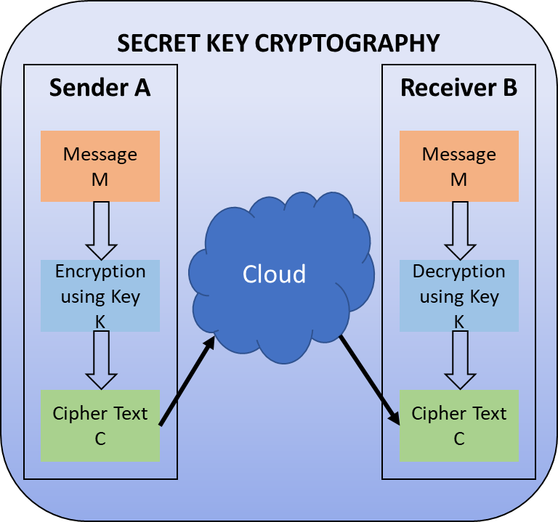**Fig 1**. Secret Key Cryptography

# V. Cryptography Mechanism

Cryptography is a method of preserving and transmitting information in a manner so it can only be accessed and analysed by individuals that are authorized to. The term is more usually associated with converting original content (normal data, often referred as plaintext) into encrypted text and subsequently back to plaintext (a practice called as decryption). The 3 kinds of cryptographic algorithms which are commonly used to fulfil such goals are symmetric key cryptography, asymmetric public-key infrastructure cryptography, and one way hashing algorithms, and every one is described here.

1. *Secret Key Cryptography*

In symmetric key encryption, a same key is utilised both for encrypting and decrypting data. The originator A uses key K for encrypting the plaintext message M (or some set of rules) and sends the encrypted text C to the recipient, as can be seen in Figure 1. The recipient employs the similar key K to decipher the encrypted text C and recover the original text M. (or ruleset). Because it employs the identical key for both operations, symmetric encryption is another name for secret key cryptography.

Inside this technique of cryptography, both the communicating parties should have the key; and besides, it is the secret. Clearly, key dissemination is by far the biggest difficult component of this technique.

The 2 primary forms of secret key data encryption are block and streaming ciphers. Streaming cyphers operate on an one bit (byte or computer word) at a moment and employ a response technique to maintain the secret updating. A block cryptosystem derives its title by the idea as it uses the similar key for encrypting single piece of information at a moment. The very similar raw unit would everytime encrypt to the identical encrypted message whenever same key is used in a block cipher, although using a stream cipher, the very similar plaintext could convert to unique ciphertext. Several modes are used for block ciphers, the most essential of which are:

1. The secret key is utilized to secure the plaintext unit and generate a ciphertext frame in the **Electronic Codebook (ECB)** method. Two similar plaintext units would everytime yield the similar ciphertext block. Although becoming the largest used block cipher method, it is susceptible to a number of brute-force attacks.
2. The **CBC (Cipher Block Chaining)** mode augments the encryption algorithm with a feedback mechanism. In CBC, the data is XORed into the subsequent ciphertext frame before the encryption. In this method, two similar plaintext chunks cannot encrypt to the equivalent ciphertext.
3. **Cipher Feedback (CFB)** mode is a self-synchronizing stream cypher that implements a block cypher. In CFB method, information would be encoded in portions shorter than the block length, that may be useful in situations such as securing dynamic interface interaction. If we used 1-byte CFB method, every input letter would've been encoded and placed in a shifts registers the very same length as the frame before being broadcasted. On the receiver side, the ciphertext is decrypted, and the packets of data in the frame (i.e., everything well outside one byte) are deleted.
4. The Output Feedback (OFB) method is a block cypher comparable to a synchronized streaming cipher. To prevent the identical text blocks from forming the identical ciphertext frame, OFB employs an intrinsic response system which is separate from all the unencrypted and encrypted bitstreams.

There are several types of streaming ciphers, but 2 jump outside the box. In self-synchronizing stream cyphers, each bit in the ciphertext is computed as a product of the previous n bits in the ciphertext. The decryption operation could stay current with the encryption procedure just by understanding where it is in the n-bit ciphertext, which is why it's termed "self-synchronizing." One problem is error diffusion, which occurs when a distorted bit is sent and results in n damaged values on the receiver side. Synchronized stream cyphers create the ciphertext independently of the data flow, but both the sender and recipient use the identical ciphertext production process. Stream cyphers don't really propagate transfer issues, but because they are periodical in design, the ciphertext will eventually reoccur.

The following are examples of secret key cryptography algorithms that are currently in use:

* **DES (Data Encryption Standard):** DES is an encryption algorithm which encrypts 64-bit chunks using a 56-bit key. According to Davis R. [4], the DES technique accepts a fixed length of stream of plaintext bits and converts it to a cipher text bit sequence of the equivalent length via a number of challenging procedures. Triple DES (3DES) [5] is a DES improvement which employs a 192-bit secret and a 64-bit frame length. This method uses the same cryptographic process as the traditional DES, but it is repeated thrice to increase the secrecy strength and mean safety period.
* **AES (Advanced Encryption Standard):** Block cipher AES [6] was designed to take the role of DES in commercial applications. It features a 128-bit frame length and multiple (128, 192, or 256-bit) length of keys. The number of underlying cycles in the cipher is determined by the key size.  For a 128-bit key ten rounds are used . Apart from its legacy DES, AES does not even have a Feistel structure. DES encrypts 32 bits in a single round, however Feistel structures do not encrypt a full block in each repetition. AES, on the other hand, uses a single loop to encrypt all 128 bits.
* **Blowfish:** Designed by Bruce Schneier [7], a symmetric 64-bit block cipher; Blowfish on Pentium/ PowerPC class system is substantially quicker than DES on a since for PC’s with big data caches and 32-bit processors the algorithm was built. The length of a key is between 32 - 448 bits. Blowfish, which had already been made freely available and is designed to replace IDEA or DES, is used in a variety of applications. It's a 16-round Feistel encryption having large key S-boxes. S-boxes accept an 8-bit feed and produce a 32-bit outcome. For each cycle, one P-array value is utilized, and following the last session, both halves of the text blocks is XOR using either of the two leftover available P entries.
* **Twofish:** [8] A 128-bit block cypher with keys of 128 bits, 192 bits, or 256 bits. It is extremely safe and versatile, having been developed for large micro-processors, smart card based micro-processors of 8 bits, and specific purpose circuitry. A group lead by Bruce Schneier developed a part of the Round 2 methods in the AES procedure. Twofish's defining characteristics include the employment of precalculated key based S-boxes and a highly complex key sequencing. The secret key is the initial half portion of an n-bit secret, whereas the remaining half is employed to adjust the data encryption (key-dependent S-boxes). The Pseudo Hadamard transform (PHT) within the SAFER encryption series is among the algorithms that Twofish uses. Twofish has a Feistel architecture, similar to DES.
* **Camellia:** [9] MEC (Mitsubishi Electric Corporation) alongwith NTT Corp. (Nippon Telegraph and Telephone) worked on a encryption key, block cypher cryptographic method during the year 2000. Camelia like AES have comparable qualities, such as a 128-bit frame structure, capability for 128/ 192/ 256-bit key values, and hardware and software solutions on major 8/ 32 bit CPUs (e.g., embedded systems, cryptographic hardware, smart cards). Camellia is a Feistel cryptography having 18 cycles (128-bit secrets) or 24 cycles (256-bit keys) (when using 192 or 256-bit keys). As a conceptual conversion level, the so-called "FL-function" or its opposite is performed each six cycles. Camellia makes use of four 8 x 8-bit S-boxes that perform affine modifications and logic functions on the intake and result. The encryption additionally employs incoming and outgoing key cleaning. The diffusion level employs a sequential modification depending on a vector having a node count of 5.
* **KASUMI:** [9], [10] The UMTS (Universal Mobile Telecommunications System), formerly referred also as 3gpp (Third Generation Partnership Project), uses a frame encryption having key length of 128 bits and block size of 64 bit. For upcoming mobile communications systems, KASUMI is a suggested messaging information and signaled information privacy and reliability method. In GPRS, KASUMI is used in both the GEA3 key streaming producer and the A5/3 key streaming producer. Dunkelman, Keller, and Shamir announced a novel related-key attack in 2010 that lets an opponent to retrieve a whole A5/3 key [11]. The foundation of KASUMI is an 8 cycles Feistel structure. The rounds operations in the fundamental Cryptosystem are permanent Feistel like networking alterations. In every cycle, a cycle secret is used, that comprises of eight 16 bit sub key-values produced by using a 128-bit key using a set key sequence.

TABLE I

PKI Applications

|  |  |  |  |
| --- | --- | --- | --- |
| **Algorithm** | **Key Exchange** | **Digital Signature** | **Encryption/ Decryption** |
| **DSS** | Close outline | Checkmark outline | Close outline |
| **Elliptic Curve** | Checkmark outline | Checkmark outline | Checkmark outline |
| **Diffie-Hellman** | Checkmark outline | Close outline | Close outline |
| **RSA** | Checkmark outline | Checkmark outline | Checkmark outline |

**Fig 2:** Public Key Cryptography

1. *Public-Key Cryptography*

Encryption and decryption are performed by utilizing two secret keys (private and public) in public-key cryptography. Although both secrets are linked mathematically, having one will hardly make it easy to find about the second. As shown in Figure 2, originator A encrypted the original data M and sends the encrypted text C to the recipient by utilizing recipient B's public key (or some set of rules). The recipient employs his or her personal private key to decode the encrypted text C and get the original message M. Because it needs a two different keys, such approach is called as asymmetric encryption. For secrecy, authentication, or both, asymmetric encryption can be utilised. Table 1 lists applications for PKI.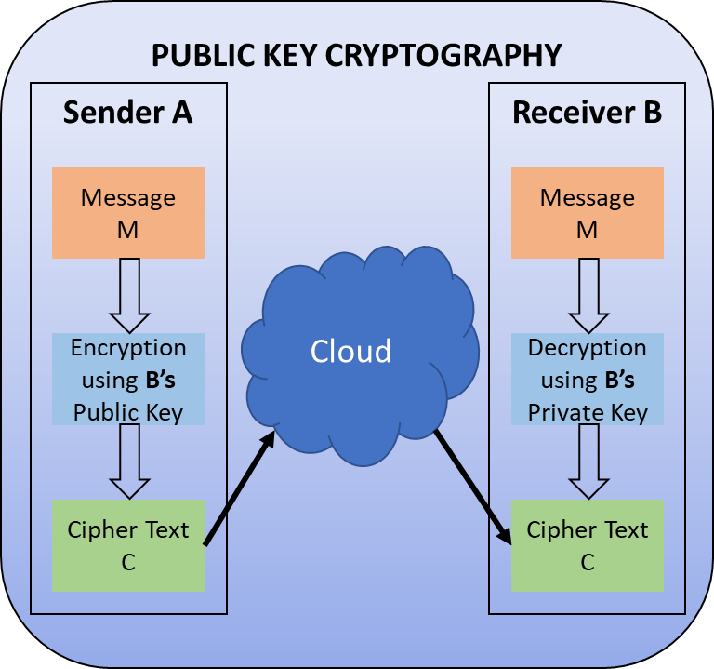

Today's PKI techniques for key exchange and digital signatures include:

1. **RSA**

The earliest and largest frequently utilized variant of PKI, titled for the 3 MIT researchers that invented it: Ronald Rivest, Adi Shamir, and Leonard Adleman [12]. RSA is presently utilised in secret key sharing, message authentication, and encryption techniques in numerous application products. RSA employs a changeable encryption frame and a varying key size. The key pair is made up of such an extremely large numeral n, that is the product of 2 prime integers chosen using certain processes; those primes can both contain 100 or even greater digits, yielding in a n having nearly double as much numerals as the prime components. The 3 stages of RSA include key creation, encrypting text , and decrypting text.

1. **DH (Diffie-Hellman) Key Exchange**

DH key transfer has been a basic public-key algorithm [13]. This protocol employs discrete logarithms based public key approach to allow two users to create a secret key. Only if the two participants' identities can be verified is the protocol safe. DH only supports secret key exchanges and does not provide services like data authenticating or message authentication. The following is the algorithm: 1) Pick 2 Universal Common integers: a prime number p and it's primitive root. 2) Key making on sender side: Originator selects a random number such that XA < p, that is secret and calculates its public part such that YA = α XA mod p. 3) Key making on recipient side: Recipient chooses a random number such that XB < p, that is his secret and calculates its public part such that YB = α XB mod p. 4) Originator determines its secret key by doing: K = (YB ) XA mod p. 5) Recipient determines secret key that is similar like originator secret key by doing: K = (YA) XB mod p.

1. **Elliptic Curve Cryptography (ECC)**

It's similar to the Key Exchange protocol using DH. [14] This PKI cryptography technique is based on ECC. A number of ECC techniques, including digital signature, encryption and key exchange, may be developed using elliptic curve arithmetic. Regarding overall objectives of ECC, given over a finite field elliptic curve equation is utilised in elliptic curve computation. A finite field is represented by the coefficients and variables in the equation. ECDLP's (Elliptic Curve Discrete Logarithm Problem) inflexibility is the basis of ECC's security.

1. **Digital Signature Standard (DSS)**

The secure hash algorithm is used in the DSS, which is a NIST standard [15]. The originator of a message include a sequence that functions as a signature is a way of providing authentication using digital signature. The signatures are frequently generated through encrypting the message's hash with the author's secret key. The message's origins and integrity are guaranteed by the signature.

The sender can use a digital signature creation technique to sign a communication. The data along with the originators private key are the algorithm's inputs. An authentication technique, in which the originator’s public key, the signature, and the message are taken as input, may be used by any other user, say the recipient, to verify the signature.

The DSS utilises a technique designed primarily to provide capabilities of digital signature. It can't be used to encrypt or exchange keys. However, it is a public-key strategy. The data which requires authenticity is put through an RSA hashing algorithm, that creates unique hash values of a predetermined size. After that, the signatures are created by encryption of the hash output utilising the originator's secret key. The text and signatures are thereafter transmitted. The message is read by the receiver, who generates a hash code. The recipient decrypts the identity utilizing public key of the originators. If a calculated hash value satisfies the deciphered signature, it is considered valid. Only the sender has access to the private key, thus only he or she could have created a valid signature.

A hash function is also used in the DSS technique. A signature function receives the hash code as well as a random integer created for this signature as input. The signature method typically employs the originator's secret key as well as a collection of attributes accessible to a number of communication protocols. This collection may be thought of as a worldwide public key PUG. As a consequence, a signature with two components, called s and r, is created.

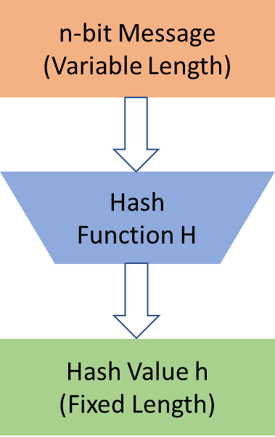

**Fig 3:** Block Diagram of Hash Function

1. *Hash Functions*

Hashing algorithms, sometimes referred to as one way encryption or message-digests, are techniques which do not use a secret in any manner. A hash algorithm H accepts a varying size frame of text M as feed and produces a predefined size hash result h = H(M), as can be seen in Fig 3. A hashing algorithm's fundamental objective is to ensure security of information. If a single bit in the hash code is changed, the hash value would most likely changes. An adaptive compressor mechanism is used in nearly each cryptographic hashing technique. Reliable hashing approaches use either of 2 kinds of compression operations: a mechanism designed specifically for the hashing feature or a symmetrical block encryption method. Illustrations of these two methods are Whirlpool and SHA, respectively [16].

# VI. Conclusion

Because of the Internet's fast expansion, security of information and network has been an unavoidable problem towards a company with an inside local network that likely is to be linked to the Internet. Securing data has becoming increasingly crucial. The security of user records in the internet is a key concern. Cryptographic systems are becoming more diverse as more mathematical tools become available, and they frequently incorporate several keys for a single application.

The research looked at a variety of cryptography approaches for securing networks. Encrypting communications with a powerful private key which both the source and destination knows is a crucial aspect of attaining comprehensive internet privacy. A vital duty is the cryptographic keys transfer among the originator and its destination. Key control assists in the security of sensitive data against illegal access. This might even examine the authenticity of a transmitted information to verify their validity. Internet privacy refers to the use of encryption techniques in networking standards and networking services. The concept of digital privacy is discussed in the paper, with an emphasis on computer networking privacy problems.

# References

|  |  |
| --- | --- |
| [1] | S. N. Kumar, "Technique for Security of Multimedia using Neural Network," *Paper id-IJRETM-2014-02-05-020, IJRETM,* vol. 02, no. 05, pp. 1-7, 2014. |
| [2] | A. Simmonds, P. Sandilands and L. v. Ekert, "An Ontology for Network Security Attacks," in *Asian applied computing conference*, Springer, 2004, p. 317–323. |
| [3] | A. Menezes, P. V. Oorschot and S. Vanstone, Handbook of applied cryptography, CRC press, 2018. |
| [4] | R. Davis, "The data encryption standard in perspective," *IEEE Communications Society Magazine,* vol. 16, no. 6, pp. 5-9, 1978. |
| [5] | N. S. P. 800-67, Recommendation for the Triple Data Encryption Algorithm (TDEA) Block Cipher, 2004. |
| [6] | J. Daemen and V. Rijmen, "The Advanced Encryption Standard Process," in *The Design of Rijndael*, Springer, 2002, pp. 1-8. |
| [7] | B. Schneier, "Description of a New Variable-Length Key, 64-Bit Block Cipher (Blowfish)," in *Fast Software Encryption, Cambridge Security Workshop Proceedings*, 1993. |
| [8] | B. Schneier, "Twofish Cryptanalysis Rumors," *Schneier on Security,* 2005. |
| [9] | M. Matsui and T. Tokita, "MISTY , KASUMI and Camellia Cipher Algorithm Development," *Mitsibishi Electric Advance (Mitsibishi Electric corp.),* 2002. |
| [10] | "General Report on the Design, Speification and Evaluation of 3GPP Standard Confidentiality and Integrity Algorithms," *3GPP,* 2009. |
| [11] | O. Dunkelman, N. Keller and A. Shamir, "A Practical-Time Related-Key Attack on the KASUMI Cryptosystem Used in GSM and 3G Telephony," *Journal of Cryptology,* vol. 27, p. 824–849, 2014. |
| [12] | R. L. Rivest, A. Shamir and L. Adleman, "A Method for Obtaining Digital Signatures and Public-Key Cryptosystems," *Communication of the ACM,* vol. 21, no. 2, 1978. |
| [13] | W. Diffie and M. Hellman, "New directions in cryptography," *IEEE Transactions on Information Theory,* vol. 22, no. 6, pp. 644-654, 1976. |
| [14] | N. Koblitz, "Elliptic curve cryptosystems," *Mathematics of computation,* vol. 48, no. 177, pp. 203-209, 1987. |
| [15] | F. 180, "Secure Hash Standard, Federal Information Processing Standard (FIPS), Publication 180," *NIST, U.S. Dept. of Commerce,* 1993. |
| [16] | M. Lamberger, F. Mendel, C. Rechberger, V. Rijmen and M. Schläffer, "Rebound Distinguishers: Results on the Full Whirlpool Compression Function," *Advances in Cryptology – ASIACRYPT,* 2009. |

1.